CHAPTER 1

Introduction
Water is a vital natural resource essential for sustaining life, ecosystems, and agricultural productivity. Among the two major types of freshwater sources surface water and groundwater the latter plays a particularly critical role in regions where rainfall is erratic and surface storage is insufficient. In India, groundwater serves as the primary source of irrigation and domestic water supply, especially during dry seasons or drought conditions. Understanding groundwater behavior, availability, and management is therefore crucial for achieving sustainable agricultural development.

Surface Water
Surface water includes rivers, lakes, tanks, ponds, and reservoirs that occur naturally or are created by human interventions on the Earth’s surface. These sources depend largely on precipitation and surface runoff and are widely used for irrigation, domestic use, industry, and hydropower. However, the availability of surface water fluctuates with seasonal and geographical variations, making it less reliable in arid or semi-arid regions.
While surface water is easily accessible, its storage capacity is limited, and it is highly vulnerable to droughts and climate variability. In southern India, for instance, rainfall variability directly affects the volume of water stored in tanks and reservoirs. Consequently, dependence solely on surface water cannot meet the growing demands of agriculture and domestic consumption. Efficient planning and integration with groundwater resources are necessary for long-term water sustainability.
1.2 Groundwater
Groundwater is the water that exists below the Earth’s surface within the pores and fractures of soil and rocks, forming aquifers. It acts as a buffer against surface water shortages, providing a steady and reliable source even during dry periods. Groundwater is generally of better quality due to natural filtration through soil and rock layers, making it suitable for drinking, irrigation, and industrial use.
In India, groundwater is accessed mainly through borewells and tube wells, which supply a major share of irrigation water. Its availability has made it indispensable for rural livelihoods and agricultural sustainability, particularly in drought-prone and semi-arid regions. However, this increased dependency has led to over-extraction and depletion, demanding better scientific understanding and management of aquifer systems.
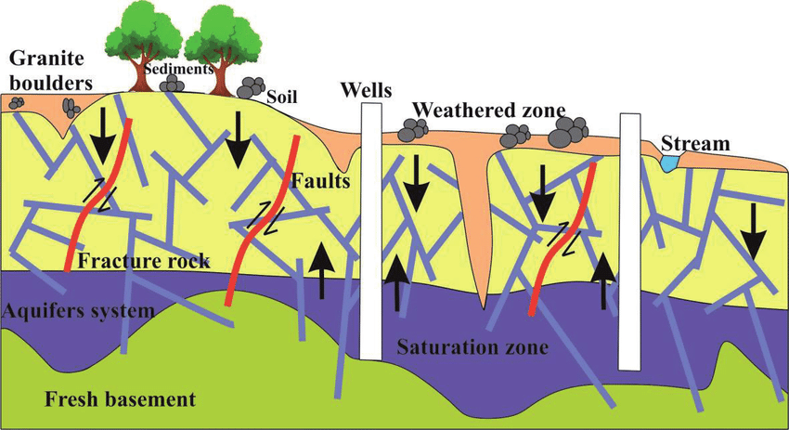
FIGURE 1.1 The figure is showing the aquifer system in fractured rock formations.

1.3 Importance of Groundwater in Agriculture
Groundwater is the backbone of Indian agriculture, accounting for more than 60% of irrigation water. It ensures year-round crop production and supports multiple cropping systems by providing water during non-monsoon periods. In hard-rock regions such as southern Karnataka, where surface water is scarce, groundwater extraction through boreholes enables farmers to cultivate even during dry spells.
It also plays a vital role in maintaining soil moisture, recharging wetlands, and supporting the base flow of rivers. Thus, groundwater not only sustains agricultural productivity but also contributes to ecological balance. Without effective groundwater management, both food security and environmental stability are at risk.

1.4 Groundwater Depletion and Scarcity
The increasing reliance on groundwater for irrigation and urban use has resulted in severe groundwater depletion. Across India, over-abstraction of groundwater has led to declining water tables, drying wells, and reduced yields, particularly in the hard-rock regions of South India. In agricultural areas, unregulated pumping and poor recharge mechanisms have worsened the imbalance between extraction and natural replenishment.
In the Gundlupet region of Mysuru District, which forms part of the Gudlu Basin, declining groundwater levels are linked to heavy borewell use and low recharge in fractured crystalline formations. The problem is compounded by climate variability, which reduces effective recharge, and urban expansion, which limits infiltration through impermeable surfaces.
These factors highlight the urgent need for scientific groundwater modeling and monitoring to assess aquifer conditions and plan sustainable extraction strategies.

1.5 Understanding Groundwater Systems in South India
The hydrogeology of South India is dominated by hard-rock crystalline formations such as granite, gneiss, and charnockite. These formations have low primary porosity, meaning groundwater occurs only in secondary features such as fractures, faults, joints, and weathered zones. The complex and discontinuous nature of these aquifers makes groundwater occurrence and movement highly variable, even within short distances.
In regions like the Gundlu (Gundlupet) Basin, groundwater is typically stored in fracture zones, which form the main productive aquifer horizons. The casing depth (CP) marks the upper weathered zone, while the first (FWD), second (SWD), and third (TWD) fracture depths represent the primary water-bearing layers. These zones define the aquifer’s productivity and control groundwater flow.
Understanding the geometry, depth, and interconnection of these fractures is essential for developing accurate groundwater models. Modelling using tools such as GMS (Groundwater Modelling System) helps in simulating subsurface conditions, predicting groundwater behavior, and designing sustainable management plans for agriculture and domestic needs.

CHAPTER 2

2. Literature Review
2.1 Overview of Groundwater Studies in Hard-Rock Terrains
Groundwater occurrence in hard-rock regions has been extensively studied because of the discontinuous and fracture-controlled nature of aquifers. Hard-rock aquifers (granite, gneiss, charnockite) lack primary porosity and depend entirely on secondary porosity, such as fractures, joints, faults, and weathered zones.
Studies by Maréchal et al. (2020) and Dewandel et al. emphasize that groundwater movement in these terrains is mainly through three layers:
- Weathered zone (saprolite)
- Shallow fractured zone
- Deep fracture network
This aligns strongly with the hydrogeology of the Gundlupet–Gudlu Basin, where borewell drilling commonly intersects multiple fractures at different depths, forming the main freshwater supply.

2.2 Aquifer Characteristics in South Indian Crystalline Formations
Several studies conducted across Karnataka, Tamil Nadu, and Andhra Pradesh highlight that crystalline aquifers show:
- Weathered zone thickness: 5–15 m
- First fracture horizon: 25–40 m bgl
- Second fracture horizon: 50–80 m bgl
- Deep fracture zones: 90–120 m bgl, often isolated
Research from the Berambadi Catchment (adjacent to Gundlupet) shows similar fracture patterns and recharge behaviors. These fractures control borewell performance, and groundwater availability depends on their continuity and interconnectivity.
CGWB (2012) and Atal Bhujal Yojana (2023–24) also report that the Gundlupet block groundwater operates within hard-rock systems characterized by low storage and rapid decline under intensive pumping.

2.3 Borewell Drilling Data and Fracture Mapping
Borehole lithology and drilling reports remain the primary source of information for fracture identification. Several authors emphasize the importance of recording:
- Casing Pipe Depth (CP) – protects shallow weathered zone
- First Water-Bearing Fracture Depth (FWD)
- Second Water-Bearing Fracture Depth (SWD)
- Third Water-Bearing Fracture Depth (TWD)
These parameters help determine the productive aquifer zones, influence borewell yield, and support groundwater model calibration.
Research in hard-rock terrains indicates:
- Borewells with two or more fractures yield significantly higher discharge
- Fractures at greater depth tend to be more isolated and provide localized storage
- The spacing and orientation of fractures correlate with geological structures such as shear zones and lineaments
These findings closely resemble the hydrogeological behavior recorded in the Gundlu Basin borewell dataset collected locally.

2.4 Groundwater Modelling in Hard-Rock Regions
Groundwater Modelling System (GMS) using MODFLOW is widely used for conceptual and numerical analysis in hard-rock terrains.
Literature shows that accurate modelling requires:
- Spatial distribution of borewell data
- Fracture-depth based aquifer layering
- Recharge estimates from rainfall and soil characteristics
- Assignment of hydraulic parameters (K, Sy, S) based on rock type
Studies by Frontiers in Water (2022) and Nature (2022) indicate that recharge in the Gundlupet region is episodic, occurring mainly during high-intensity rainfall events.
Thus, models must account for low base recharge, fracture-controlled flow, and spatial heterogeneity.
2.5 Groundwater Depletion and Over-Extraction in Semi-Arid India
Several reports highlight the rapid decline of groundwater levels due to over-abstraction for agriculture.
India, being the largest user of groundwater globally, relies on borewells for over 60% of irrigation.
In Karnataka, particularly Mysuru and Chamarajanagar districts:
- High dependency on borewells
- Low recharge due to crystalline rock
- Increasing depth to water table
are key indicators of stress.
The Gundlu Basin shows similar patterns, making it a critical area for groundwater modelling and sustainability assessment.

CHAPTER 3

3. Study Area

3.1 Location and Geographic Setting
The study area, Gudlu Basin, is located in Gundlupet Taluk, situated in the southern part of Karnataka, under Mysuru–Chamarajanagar region. It forms part of the Kabini River sub-basin, which ultimately drains into the Cauvery River system.
The basin lies within a semi-arid climatic zone characterized by moderate rainfall, uneven distribution of monsoon precipitation, and high evapotranspiration. The topography is gently undulating, with elevations ranging from 750–900 m above mean sea level.
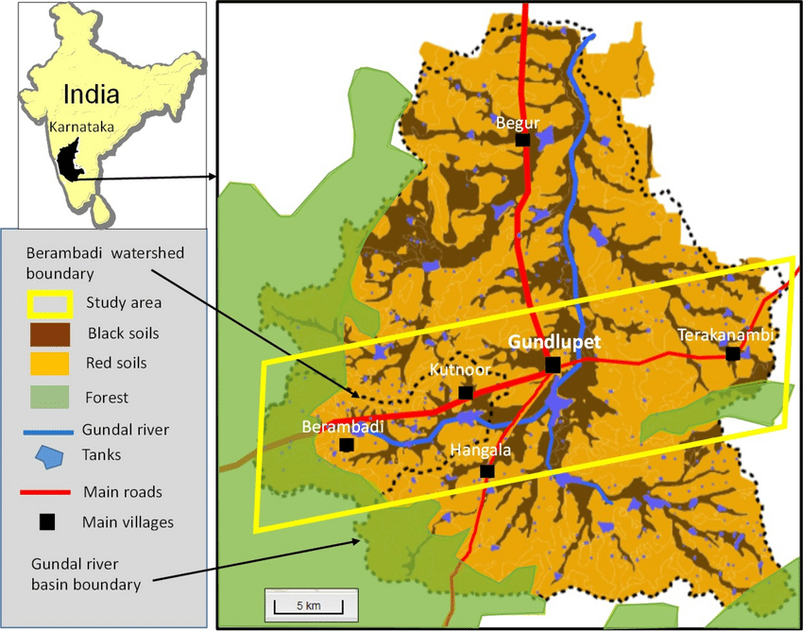
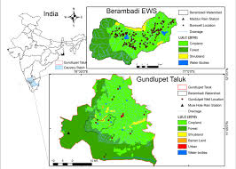
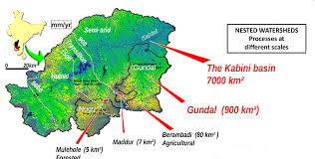

3.2 Climate and Rainfall
The study area experiences a tropical semi-arid climate with three major seasons:
- Summer: March–May (high temperatures 32–36°C)
- Monsoon: June–October (major rainfall period)
- Winter: November–February
Average annual rainfall ranges from 650–800 mm, mostly received during the southwest monsoon. Intense short-duration rainfall events contribute significantly to episodic recharge, a key characteristic of hard-rock aquifers in southern India.

3.3 Geological and Lithological Characteristics
The Gudlu Basin is underlain by Precambrian crystalline hard rocks, predominantly:
- Granite gneiss
- Hornblende-biotite gneiss
- Charnockite
- Granulite
- Dolerite dykes and minor quartz veins
These rocks have very low primary porosity, and groundwater is stored mainly in:
- Weathered zone (saprolite)
- Fractured crystalline bedrock
- Jointed and sheared rock zones
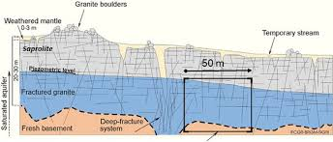
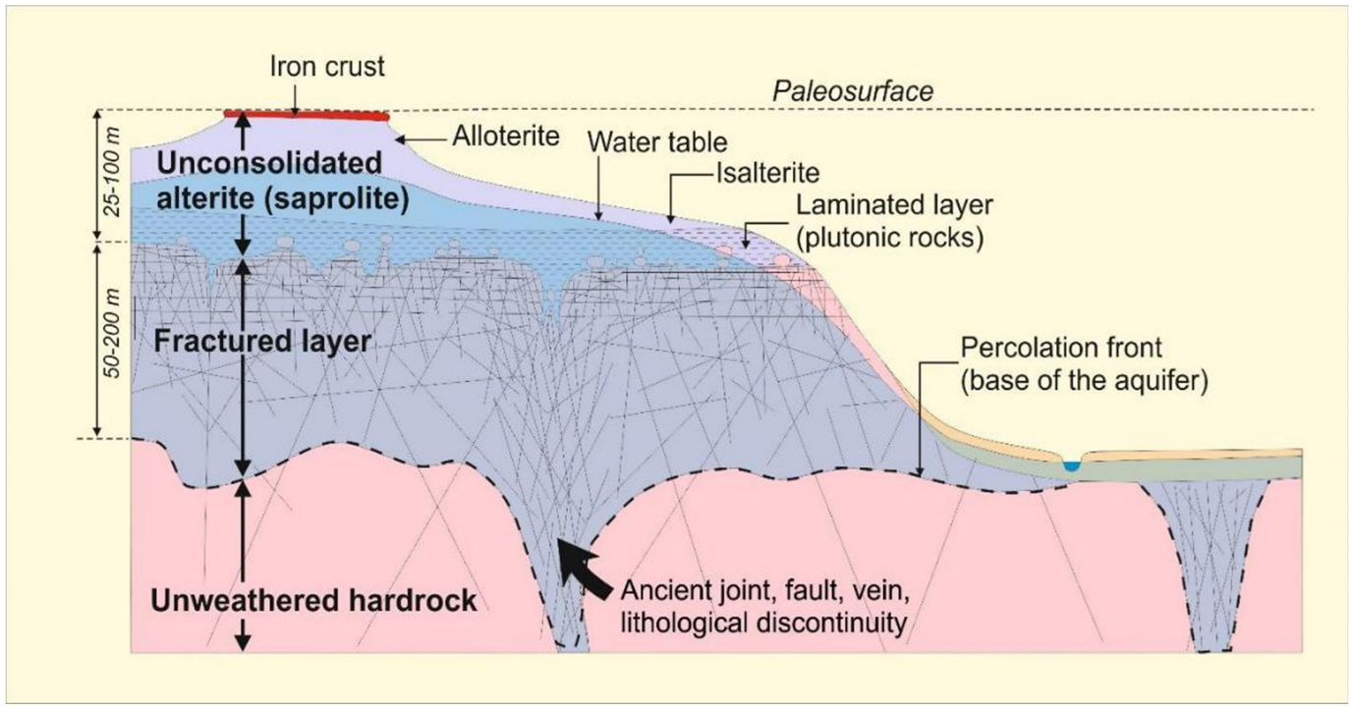
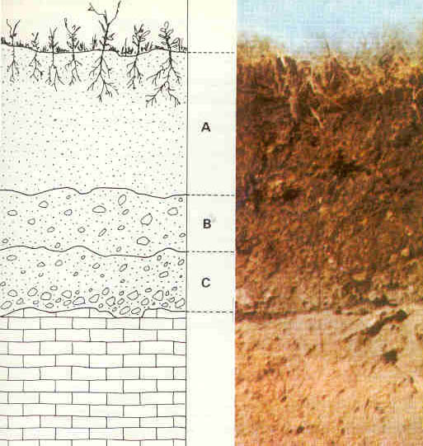
This lithological setting is typical of southern Karnataka’s hard-rock terrain and directly influences borewell success and aquifer productivity.

3.4 Hydrogeology of the Study Area
Groundwater in the Gundlu Basin occurs in weathered and fractured crystalline aquifers.
The aquifer system is vertically divided into:
- Weathered Zone (5–15 m)
  - Mostly clay, sandy clay, or disintegrated gneiss
  - Low permeability, acts as a shallow storage and recharge zone
- Shallow Fracture Zone (15–40 m)
  - Contains first water-bearing fracture (FWD)
  - Most productive layer for borewell yield
- Intermediate Fracture Zone (40–80 m)
  - Contains second fracture (SWD)
  - Moderate transmissivity; supports irrigation wells
- Deep Fracture Zone (80–120 m)
  - Contains third fracture (TWD)
  - Highly variable; productive only if intersecting major structural features
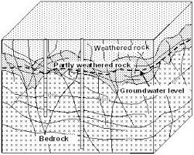

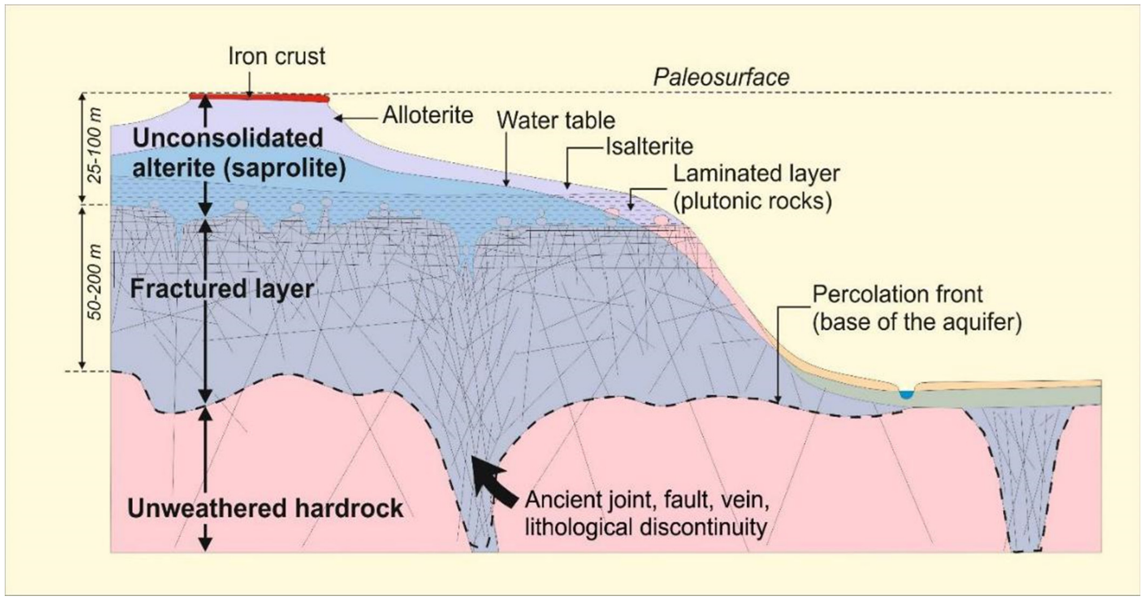
The fracture-controlled nature of these aquifers explains the large variation in borewell yields within short distances.

3.5 Borewell Development and Aquifer Parameters
In the study area, borewells are drilled up to 120–180 m depth, depending on terrain and expected fractures.
Field data collected for this project included:
- Casing Pipe Depth (CP) – usually 6–12 m through the weathered zone
- First Water-Bearing Fracture Depth (FWD) – averages 25–40 m
- Second Fracture Depth (SWD) – occurs between 55–80 m
- Third Fracture Depth (TWD) – appears between 90–120 m
These fracture depths were obtained directly from local drilling logs and cross-verified with regional hydrogeological studies.
Hydraulic parameters (based on CGWB & research papers):
- Hydraulic Conductivity (K): 0.2–10 m/day
- Specific Yield (Sy): 0.01–0.03
- Transmissivity (T): 10–65 m²/day
Such values confirm the low-yield, high-variability nature of hard-rock aquifers.

3.6 Land Use and Recharge Characteristics
Land use in the basin consists of:
- Agricultural fields (ragi, maize, pulses, sugarcane)
- Scrub and fallow land
- Small forest patches
- Built-up village clusters
Recharge mainly occurs through:
- Rainfall infiltration in weathered zone
- Lineaments and fracture intersections
- Agricultural fields (indirect recharge)
Because of crystalline rock, recharge is localized and episodic, not uniform.

CHAPTER 4

DATA PRODUCTS AND METHODOLOGY

4.1 Borehole Data Set (Primary Field Data)
The primary dataset used in this study was collected directly from local borewell drillings conducted within the Gundlu Basin of Gundlupet Taluk (Mysuru/Chamarajanagar District). These borehole logs provide essential information on subsurface conditions of the hard-rock aquifer system and are the foundation for groundwater modelling.

4.1.1 Data Collected from Borewell Drillers
The following parameters were recorded at each borewell site:

a. Casing Pipe Depth (CP)
The casing pipe depth represents the depth (in meters) up to which the borewell is cased to prevent collapse in the weathered or loose zone.
It also marks the top boundary of the productive fractured aquifer.
- Typical CP values in Gundlu Basin: 6–12 m
- Function: Prevent soil collapse, isolate top non-aquifer zone, allow deeper fractures to be accessed.

b. Borehole Location (Latitude and Longitude)
The exact geographic coordinates of each borewell were obtained using a GPS-enabled device.
These coordinates are essential for:
- Plotting borewell positions in QGIS/ArcGIS
- Importing well locations into the GMS groundwater model
- Interpolating aquifer layers and fracture networks spatially
Coordinates recorded include:
- Latitude (°N)
- Longitude (°E)
These were stored in decimal-degree format for direct compatibility with GIS and modelling software.

4.1.2 Use of Borehole Data in Groundwater Modelling
The collected borehole data serve multiple roles in this research:
- Casing Pipe Depth (CP)
  - Defines the thickness of the weathered zone
  - Helps identify the upper boundary of the aquifer model layer
  - Used in creating vertical aquifer profiles in GMS
- Latitude & Longitude
  - Used to georeference each borehole on the map
  - Imported into GMS as Observation Wells
  - Helps generate spatial datasets such as 3D block models, fence diagrams, and cross-sectional views
The accuracy of coordinates ensures correct alignment of borewell data with DEM, geological maps, recharge zones, and other spatial layers.

4.2 Methodology Overview
The methodology adopted in this study aims to develop a conceptual and numerical groundwater model for the Gundlu (Gundlupet) Basin, southern Mysuru District. The model is built using locally collected borehole drilling data, combined with regional hydrogeological information from CGWB, Atal Bhujal Yojana, and published research. The workflow includes data collection, preprocessing, GIS mapping, definition of aquifer geometry, and conversion of all datasets into GMS-compatible inputs.

4.2.1 Data Collection
Primary Data (Local Borewell Drillers)
Primary data were collected from multiple locally drilled boreholes. For each borewell, the following details were recorded:
- Casing Pipe Depth (CP)
- First Fracture Depth (FWD)
- Second Fracture Depth (SWD)
- Third Fracture Depth (TWD)
- Total Depth (TD)
- Static Water Level (SWL)
- Yield (LPM)
- Latitude & Longitude (GPS coordinates)
These logs were verified through field visits and interactions with drill operators and landowners.

Secondary Data
Additional datasets came from:
- Atal Bhujal Yojana hydrogeology reports (2023–24)
- CGWB District Reports (Mysuru, Chamarajanagar)
- Research studies on hard-rock aquifers (Frontiers, Springer)
- Remote sensing datasets (DEM, drainage, land use)

4.2.2 Data Processing and Interpretation
Borehole data were organized in Excel and mapped in QGIS. Each dataset included:
- Borehole ID, Latitude, Longitude
- CP, FWD, SWD, TWD
- TD, SWL, Yield, Aquifer Type
Missing fracture depths were estimated using typical crystalline rock patterns (FWD 20–40 m, SWD 50–80 m, TWD 90–120 m). Outliers were cleaned prior to modelling

